# REST - Country Web Service

# Project Structure –

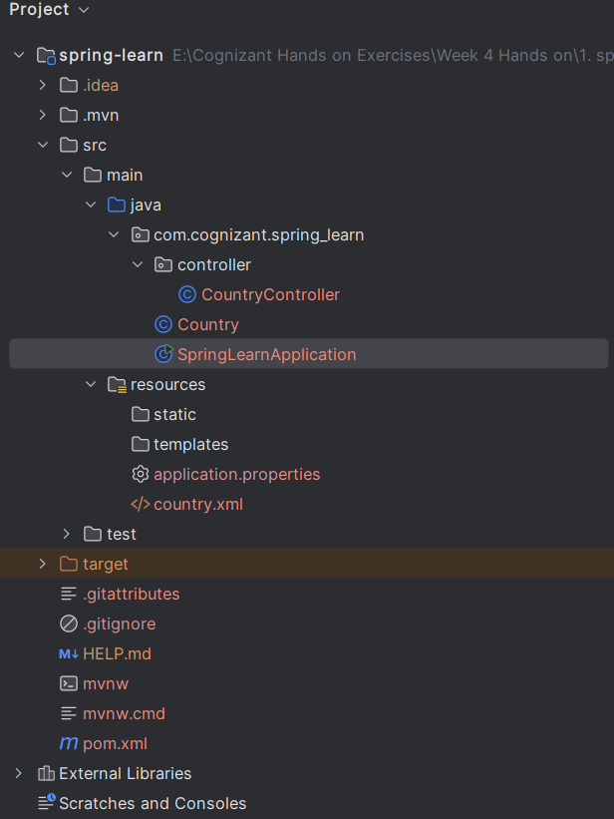

# Country.java –

# 

# Country.xml –

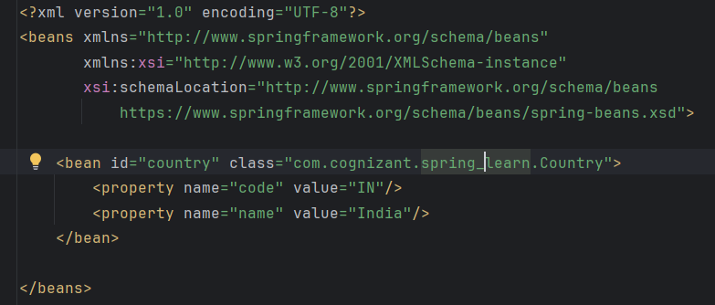

# countryController.java –

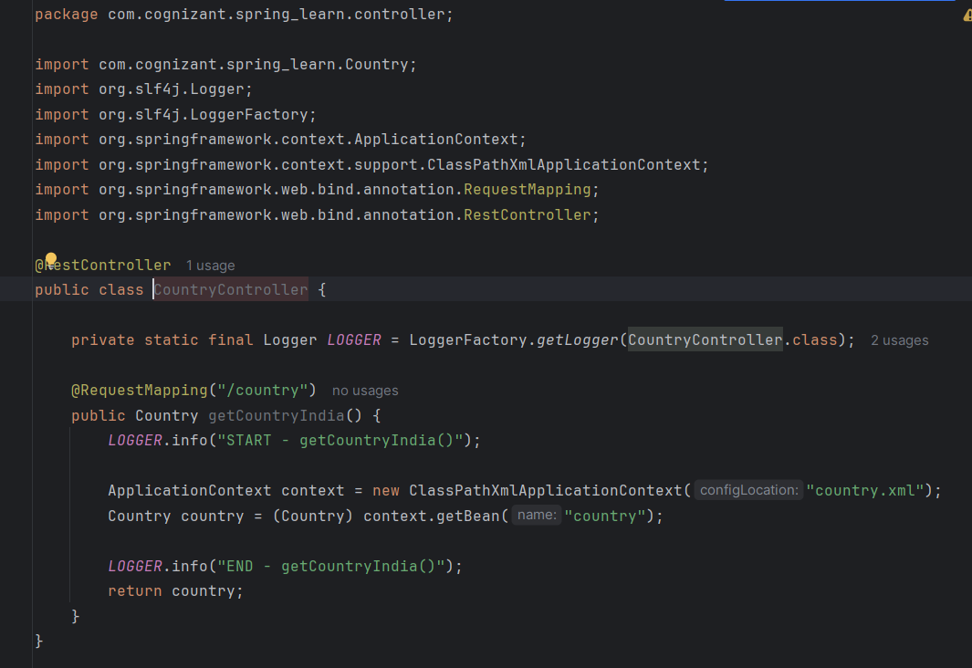

# Main class –

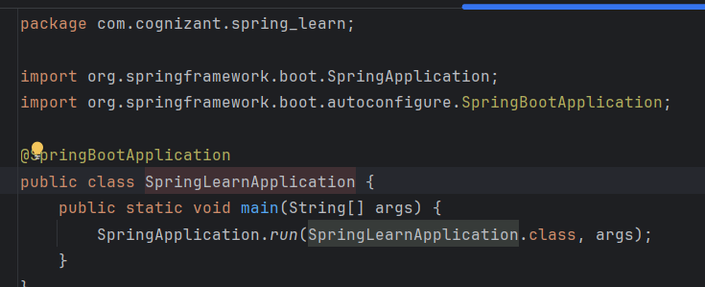

# Output –

# On - <http://localhost:8083/country>

